Fastrack Eagle Project
Design Qualification Test Procedure
for CCTV

Approved by | 1. Feb. 2012 | J.W. Park | 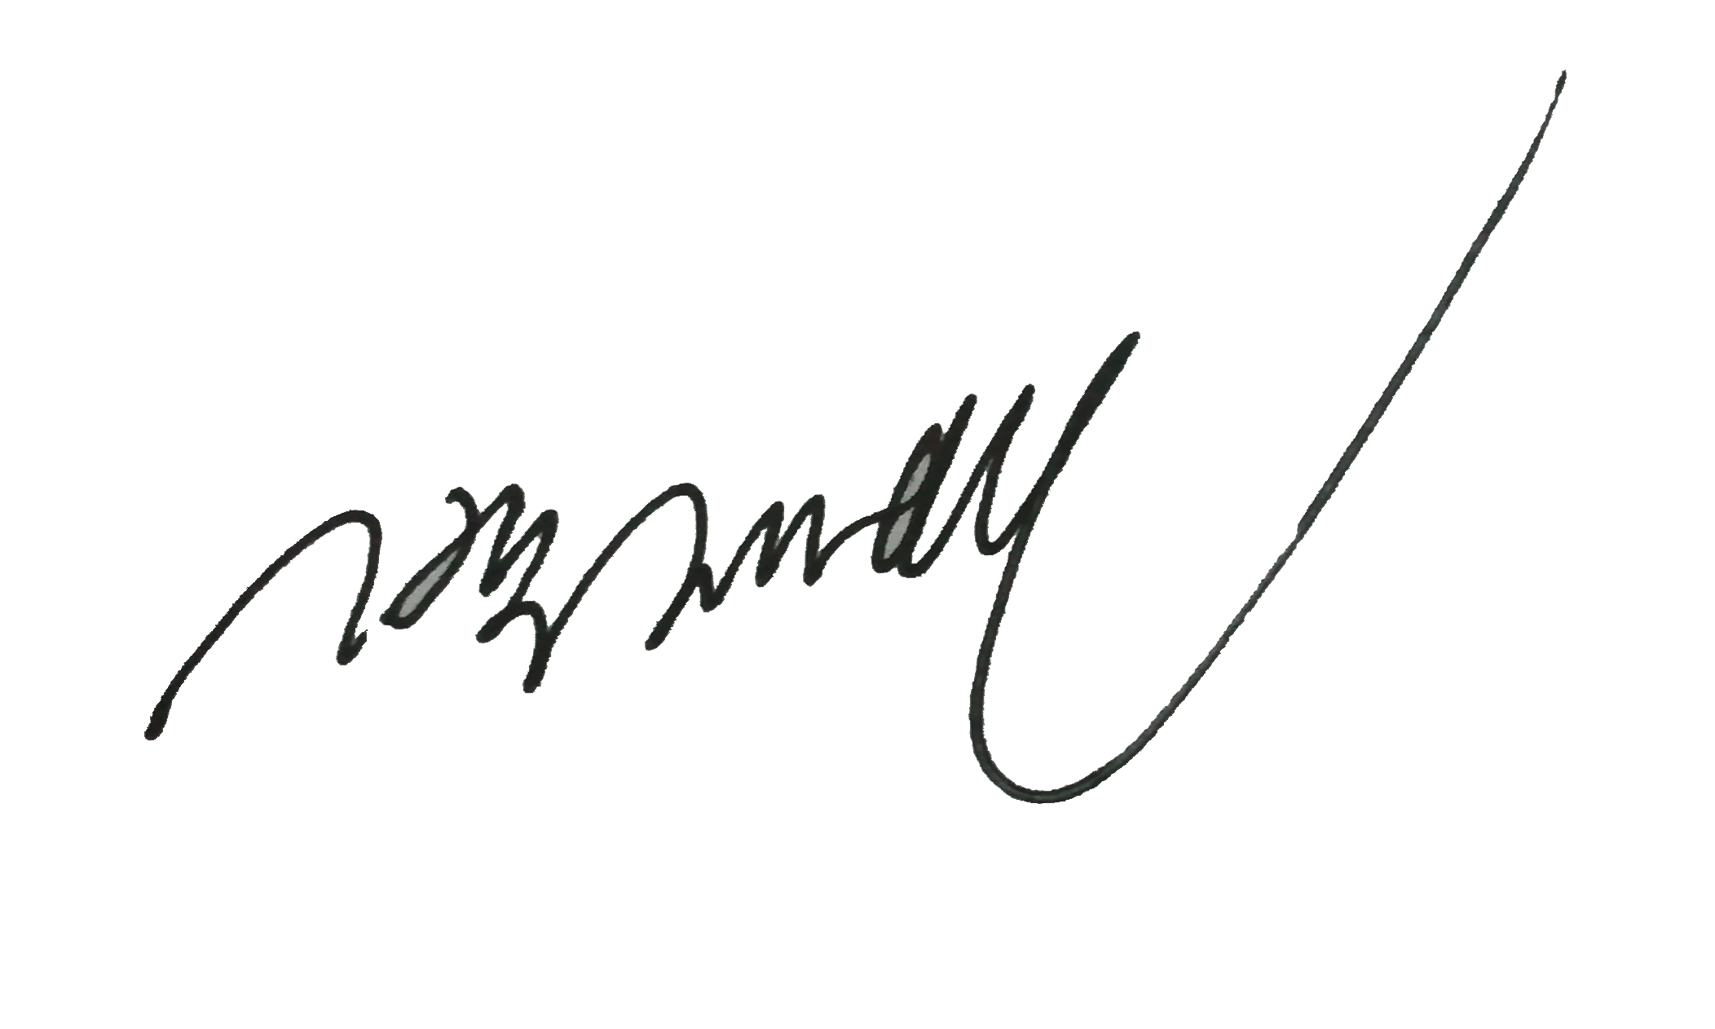
Reviewed by | 31. Jan. 2012 | H.S. Yang | 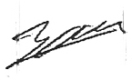
Written by | 30. Jan. 2012 | J.C. Park | 
 | Date | Name | Signature
Revision History

Issue | Page | Revision |  | Date
Issue | Page | From | To | Date
0 |  |  | First issue | 2011. 10. 31
1 | Page 9.  Page 10.  Page 12.  Page 20.  Page 21.  Page 26.  Page 28.  Page 33~52. | First issue | Revised  - Section “1.6 Test classification” Revised.  - Section “1.6.2 Standard Test” Revised.  - Section “2.2 Weight” Revised.  - Section “2.13 Power consumption” Revised.  - Section “2.15 Voltage withstand Test” Revised.  - Section “2.18 EMC test: IEC 62236-3-2” Revised.  - Section “2.18.2.4 Surges immunity test” Revised.  -“Inspection sheet” Revised. | 2011.11.30
2 | Page 7  Page 9~11  Page 14  Page 17  Page 18  Page 21  Page 24~26  Page 40, 50~53, 56~60 | Second issue | Revised  - Section “1.3 Test Equipment” Revised.  - Section “1.6 Test classification” Revised.  - Section “2.3 PoE Operation Test” Revised.  - Section “2.8 HDD Capacity” Revised.  - Section “2.10 Operation & Combination” Revised.  - Section “2.14 Continuity Test” added.  - Section “2.17 Temperature test” Revised.  - Section “2.21 Waterproof and Dust Test” added  - “Inspection sheet” Revised. | 2012.2.1
3
4
5

Contents
1 General 7
1.1 Introduction 7
1.2 Test Procedure 7
1.3 Test Equipment 7
1.4 Expected test schedule and location 7
1.5 Testing Location 8
1.6 Test classification 9
1.6.1 Type & Routine (FAI) Test. 9
1.6.2 Standard Test 11
2 Test Procedure 12
2.1 Visual & Dimension Inspection 12
2.2 Weight 13
2.3 PoE Operation Test 14
2.4 Video Resolution Variable Test 14
2.5 Video Frame rate Test 15
2.6 Protocol Test 15
2.7 RTP/RTSP Streaming Test 16
2.8 HDD Capacity 17
2.9 CCTV Monitor Display Resolution 18
2.10 Operation & Combination test 18
2.11 Aging test 19
2.12 Power supply range (Performance) test 20
2.13 Power consumption 20
2.14 Continuity Test 21
2.15 Insulation Resistance Test 21
2.16 Voltage withstand Test 22
2.17 Temperature test 23
2.17.1 Dry heat test (IEC60068-2-2) 23
2.17.2 Damp heat test (IEC60068-2-30) 24
2.17.3 Cooling test (IEC60068-2-1) 25
2.18 Semi-Conductor Burn-in Test 26
2.19 EMC test: IEC 62236-3-2 (External Test Facility) 27
2.19.1 Emission tests and limits 27
2.19.1.1 Conducted Emissions 27
2.19.1.2 Radiated Emissions 28
2.19.2 Immunity tests and severities 28
2.19.2.1 Electrostatic Discharge immunity test 28
2.19.2.2 Immunity to Radio –Frequency Electromagnetic Fields 29
2.19.2.3 Electrical Fast Transient/Burst immunity test 29
2.19.2.4 Surges immunity test 29
2.19.2.5 Immunity to conducted disturbances inducted by radio-frequency filed 30
2.20 Shock and Vibration test: IEC61373 (External Test Facility) 31
2.20.1 Vibration test 32
2.20.2 Shock test 32
2.21 Waterproof and Dust Test: IEC 60529 (External Test Facility) 34
2.21.1 Waterproof test 34
2.21.2 Dust test 34

Abbreviations

Abbreviations | Description
CCTV  FPS  HDD  HTTP  IP  DVR  PoE  PSSS  RTP  RTSP  TCP  IEC  EMC  EMS  EMI  NIST  RMS  DOC | Close Circuit Television  Frames per Second  Hard Disk Drive  Hyper-Text Transfer Protocol  Internet Protocol  Digital Video Recorder  Power over Ethernet  Passenger Saloon Surveillance System  Real Time Protocol  Real Time Streaming Protocol  Transmission Control Protocol  INTERNATIONAL ELECTROTECHNICAL COMMISSION  ELECTROMAGNETIC COMPATIBILITY  ELECTROMAGNETIC SUSCEPTIBILITY  ELECTROMAGNETIC INTERFERENCE  NATIONAL INSTITUTE OF STANDARDS AND TECHNOLOGY  ROOT MEAN SQUARE  DECLARATION OF CONFORMITY

General

Introduction
This document contains the procedure for qualification testing of the CCTV system for Denver RTD EMU.

Test Procedure
The purpose of this document is verifying the procedure about the qualifying examination of the CCTV System at RTD/DTO. The tests to be performed include environmental, shock, vibration, and EMC. At various stages of the qualification test, the CCTV system will be tested to the production test specification with the exception of the hi-pot and megger tests to verify unit function. Due to the degradation of the equipment during a hi-pot and megger test, this will only be performed on the first test and the final test. Testing can be performed in any order depending on test equipment availability.

Test procedures are divided 3 parts.
- TEST FOR EMC,(EMS,EMI), IMPACT AND VIBRATION
- TEST FOR ENVIRONMENT AS LIKE TEMPERATURE AND HUMIDITY
- TEST FOR BASIC STANDARD
.
As follow the test procedures, it should be verified based on the technical standard at each part.

Test Equipment
No. | Equipment | Drawing NO.
1 | Interior Camera | DENVER-INT001
2 | Outside Camera | DENVER-OS001
3 | Front Facing Camera | DENVER-FFC001
4 | CAB Camera | DENVER-CAB001
5 | Digital Video Recorder | DENVER-DVR001
6 | PoE Hub | DENVER-POE001
7 | CCTV Monitor | DENVER-MON001
8 | Jumper Coupler | DENVER-JC001
9 | Receptacle | DENVER-RE001

Expected test schedule and location
Schedule to visit the test laboratory: 24~29 February. 2012/ EMC, Shock & Vibration [SGS TESCO]
- The schedule and location can be flexible.

Testing Location
-SK TECH CO. LTD
820-2, Wolmoon-Ri, Wabu-Up, Namyangju-Si, Kyunggi-Do, Korea

-KOREA ENVIRONMENT & MERCHANDISE TESTING INSTITUTE
459-28, Gasan-Dong, Geumcheon-Gu, Seoul, Korea

-DAEJEON TECHNOPARK
694, Taprip-Dong, Yuseong-Gu, Daejeon, KOREA

Test classification

Type & Routine (FAI) Test.
 | Type  test | Routine(FAI) test | Test Equipment |  |  |  | Relevant  Standards
 | Type  test | Routine(FAI) test | Cameras | PoE | DVR | Monitor | Relevant  Standards
Inspection
Visual | O | O | O | O | O | O | Refer to FDR design drawing
Dimension | O | O | O | O | O | O | Refer to FDR design drawing
Weight | O | — | O | O | O | O | Refer to FDR design drawing
Tests
PoE (Power Over Ethernet) | O | O | O | O | — | — | TS Requirements 12.2(a)
Video Resolution Variable | O | O | O | — | — | — | TS Requirements 12.2(d), 3.17.2(d)
Video Frame Rate | O | — | O | — | — | — | TS Requirements 12.2(d), 3.17.2(d)
Protocol Test | O | — | — | — | O | — | TS Requirements 12.2(d), 3.17.2(d)
RTP/RTSP Streaming | O | — | — | — | O | — | TS Requirements 12.2(d), 3.17.2(d)
HDD Capacity | O | — | — | — | O | — | TS Requirements 12.2(d)
Display Resolution | O | O | — | — | — | O
Operation &  Combination | O | O | O | O | O | O | TS Requirements 3.17.2(e)
Rotakin Test | O | — | O | — | — | —
Aging | — | O | O | O | O | O
Power supply Range | O | — | — | O | O | O
Power consumption | O | — | — | O | O | O
Continuity | O | O | — | O | O | O
Insulation Resistance | O | O | — | O | O | O | APTA SS-E-001-98
Voltage withstand | O | O | — | O | O | O | APTA SS-E-001-98
Temperature | O | — | O | O | O | O
EMC | O | — | O | O | O | O
Shock & Vibration | O | — | O | O | O | O
Waterproof and Dust test | O | — | — | — | — | —
Note : 8 pieces of cameras can be connectable to one PoE receives the power and operate. Therefore PoE shall test related Power.
Waterproof and Dust test is tested on Outside Camera and Jumper Coupler only.
O = To be tested. — = Not Applicable
Test Facilities, Equipment and measurement tools
- Vernier Calipers
    - Serial number / Calibration number: 1101962-42 / 7017227
- Weight scale
- Laptop computer[Web browser, CMS]
- DC Power Supply
    - MODEL : POWER SUPPLY
    - Manufacture : TDK
    - Model name : GEN150-5-D
    - Input rating : 100-240V ~9.5A 50/60Hz
    - Serial number/ Calibration number: 821471 / 1101962-52
- WITHSTANDING VOLTAGE Tester
    - MODEL : WITHSTANDING VOLTAGE TESTER
    - Manufacture: KIKUSUI
    - Model: TOS5051
    - Serial number / Calibration number: GG001281 / GM-0500-01
- Insulation Tester
    - MODEL : MY40-01
    - Manufacture : YOKOGAWAI
    - Serial number / Calibration number: 85NA0370 / 1102074-6

Standard Test
The following tests will be carried out to system at certified site.
No. | Test Specimen | Criteria | Test Item | Test Standard | To be tested | Remark
1 | CCTV System | EMC  (EMI  &EMS) | Conducted Disturbance | CISPR 11 | ■YES □NO
2 | CCTV System | EMC  (EMI  &EMS) | Radiated Disturbance | CISPR 11 | ■YES □NO
3 | CCTV System | EMC  (EMI  &EMS) | Electrostatic Discharge | IEC 61000-4-2 | ■YES □NO
4 | CCTV System | EMC  (EMI  &EMS) | Radio-frequency electromagnetic field. Amplitude modulated | IEC 61000-4-3 | ■YES □NO
5 | CCTV System | EMC  (EMI  &EMS) | Fast transients | IEC 61000-4-4 | ■YES □NO
6 | CCTV System | EMC  (EMI  &EMS) | Surges | IEC 61000-4-5 | ■YES □NO
7 | CCTV System | EMC  (EMI  &EMS) | Radio-frequency common mode | IEC 61000-4-6 | ■YES □NO
9 | CCTV System | Shock & Vibration | VIBRATION, SHOCK & BUMP TEST | IEC 61373 Edition2.0 :2010 Class 1-A | ■YES □NO
10 | CCTV System | Temperature | Temperature | IEC60068-2-2, IEC60068-2-30  IEC60068-2-1 | ■YES □NO

Test Procedure

Visual & Dimension Inspection
- Objective
CCTV equipment should confirm that the construction of equipment to meet the approved drawing and there shall be nothing wrong in appearance (margin of error is mentioned at each drawing). However, any different specification due to customer’s request or design change at the late stage of the development shall be tested following the change reasonably.

- Criteria
Allowable tolerance in drawings

- Test Methodology
Check the size following the drawing of each component
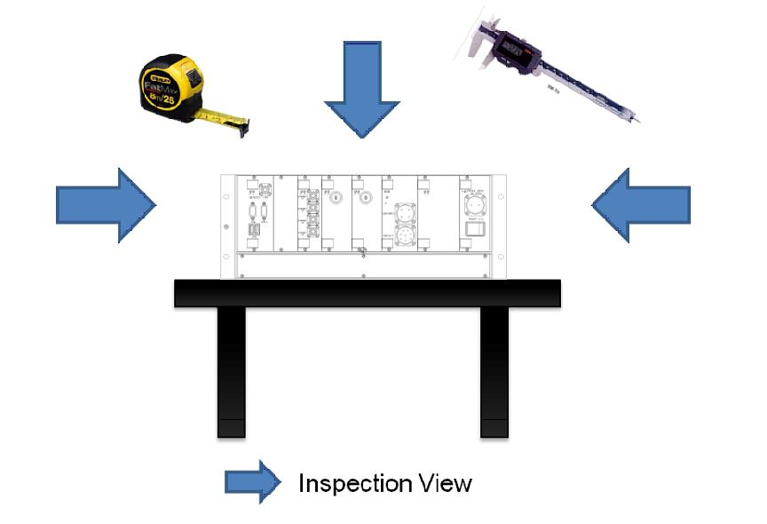
Figure 1. Expected Test Environment for Appearance Inspection

Weight
- Objective
Not to cause the installation problem, it should be checked the component weight.

- Criteria
Refer to the below table.

- Test Methodology
Each equipment’s weight measurement shall satisfy with factors below.
No. | Equipment | Drawing Ref. | Criteria
1 | Interior Cameras | DENVER-INT001 | less than 1.0kg
2 | CAB Camera | DENVER-CAB001 | less than 1.0kg
3 | Front Facing Camera | DENVER-FFC001 | less than 2.5kg
4 | Outside Camera | DENVER-OS001 | less than 3.3kg
5 | PoE(Power over Ethernet) | DENVER-PoE0001 | less than 5.4kg
6 | DVR(Digital Video Recorder) | DENVER-DVR001 | less than 10kg
7 | CCTV Monitor | DENVER-MON001 | less than 3.4kg
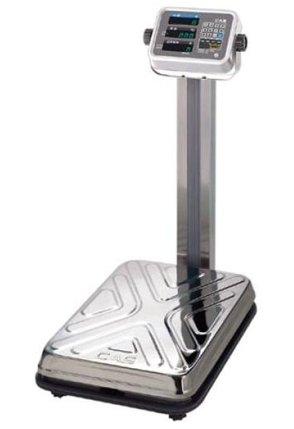
Figure 2. Expected Test Environment for Weight Inspection

PoE Operation Test
- Objective
Check operation PoE Hub status test after connecting Cameras to PoE ports of PoE Hub.

- Criteria
Camera shall be turned on.
The Image of Camera shall be checkable through monitor of Laptop.

- Test Methodology
Cameras must be operated normally of web browser at the Laptop computer.

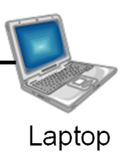
IP Camera
PoE HUB

DC 37.5V Power
DVR

Figure 3. Expected Test Condition for PoE Hub Test

Video Resolution Variable Test
- Objective
Check the camera working properly and controlling saving capacity of DVR.
- Criteria
Video Resolution Variance Range: 720x480 pixels

- Test Methodology
After organizing the test as in figure 3, the test verifying availability of the variance of Camera video resolution through video recorder is done.

Video Frame rate Test
- Objective
Check the camera working properly and controlling saving capacity of DVR.
- Criteria
Criteria of Video Frame rate: 1000Kbps
- Test Methodology
Check frame rate with Web Browser with live video display
Refer to the above Test Configuration shown as Figure 3.

Protocol Test
- Objective
Check the camera to transmit the proper video image.
TCP/ IP, HTTP, RTP, RTSP, support check in Spec sheet or Camera web browser.
- Criteria
TCP/IP: Laptop connect view
HTTP: Web browser connect view
Check the RTP/RTSP Streaming Transmission of screen through VLC Software
- Test Methodology
Refer to the above Test Configuration shown as Figure 3.

RTP/RTSP Streaming Test
- Objective
Check the camera to transmit the proper video image to OCC.

- Criteria
Check the RTP/RTSP Streaming Transmission of screen through VLC Software

- Test Methodology
Refer to the below Test Configuration shown as Figure 4.

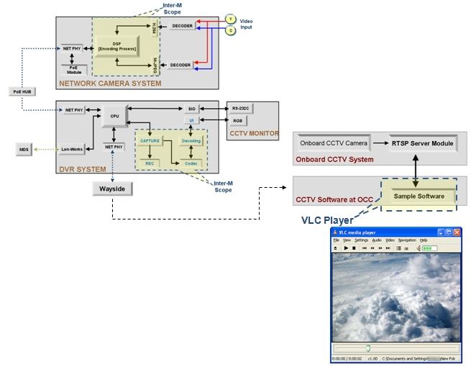
Figure 4. Expected Test Condition for RTSP Streaming Test

HDD Capacity
- Objective
Check the HDD Capacity to save 15fps, D1 and 16CH for 72 hours.
- Criteria
The recorded HDD Capacity should be comprised in the below chart.
- Test Methodology
Connect 1 camera to DVR and record 1 hour in D1, 15fps, and check the figure should be 500 Mbyte or under(refer to the below chart).
After identifying the features of video recorder’s hardware, it is identified if it is constituted with 2.5” HDD, and the overall sum storage capacity is calculated. 500GigaBytes x 2ea

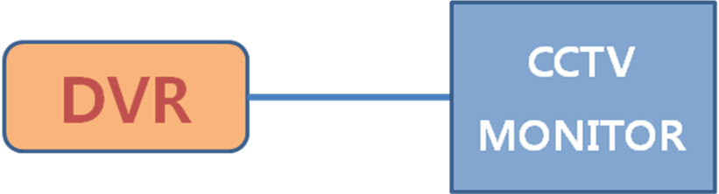
CAM

HDD Recording capacity

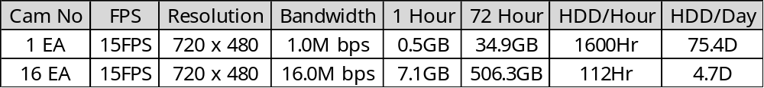
Figure 5. Expected Test Environment for HDD Capacity Check

CCTV Monitor Display Resolution
- Objective
Main parts of CCTV Monitor are verified through human eyes.
Check the CMS Software is showing properly on the monitor screen.

- Criteria
CCTV Monitor Display Resolution: XVGA (1024x768 pixels)

- Test Methodology
Refer to the below Test Configuration shown as Figure 6.

Operation & Combination test
- Objective
Check the all equipments are working properly without an error and problem.

- Criteria
Operation error is not allowed.

- Test Methodology
CCTV system shall be able to be easily controlled by user on touch screen.
Consist of the equipments as like Figure 6 and operate.
Real time video images shall be shown on CCTV Monitor while being recorded in hard disk installed in DVR. The recorded video images shall be searched and played by operation of touch screen program.
Lonworks communication data check the between MDS and DVR by “Lonscanner FX Protocol Analyzer” Tool or Serial Data check.
Video Streaming data check used VLC by SECTION 2.7.
DVR Function can be checked on the monitor.
- Automatic darkening of the CCTV monitor at speed
- Automatic display of exterior cameras when doors are open
- Display of cameras on the CCTV monitor from connected married pairs

Camera
PoE Hub
DC 37.5V Power
DVR
CCTV
Monitor
X
8
MDS
OCC
Figure 6. Expected Test Environment for Operation & Combination test
Figure 6. Expected Test Environment for Operation & Combination test

Aging test
- Objective
Check that there is no problem on the temperature and operating when you operate the equipments for a long time.

- Criteria
Operation error is not allowed.

- Test Methodology
Test the equipment in basic operation for 72 hours in normal temperature condition.
It should be checked on proper operation and taking pictures. Checking the operation 36 hours later after starting the test, checking the operation 72 hours later after the test and test close.

Power supply range (Performance) test
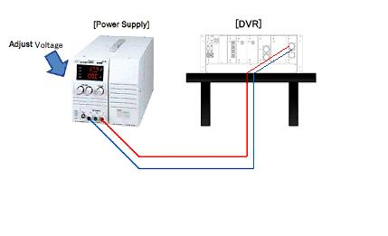
Figure 7. Expected Test Environment for Power supply range (Performance) test

- Objective
Checking the operation is well when the voltage is changed in tolerance (-30%, +25%).

- Criteria
It must run normally when the power supply is changed from DC 24 up to 47V.

- Test Methodology
Checking the operation is well when the voltage is changed and the power input is connected to DC Power Supply as Figure 7.

Power consumption
- Objective
Check the power consumption not to occur the deficiency of the power consumption.

- Criteria
Standard value is following chart.
No. | Equipment | Drawing Ref. | Criteria
1 | PoE(Power over Ethernet) Hub | DENVER-POE001 | less than 160W
2 | DVR(Digital Video Recorder) | DENVER-DVR001 | less than 100W
3 | CCTV MONITOR | DENVER-MON001 | Less than 25W
Refer to the above Test Configuration shown as Figure 7.

- Test Methodology
Power consumption which is measured by each of the input terminals shall conform to the standard values prescribed on the status of rated output.

Continuity Test
Continuity test is performed prior to insulation resistance test to verify that the wiring has been installed and terminated as designed.

Insulation Resistance Test
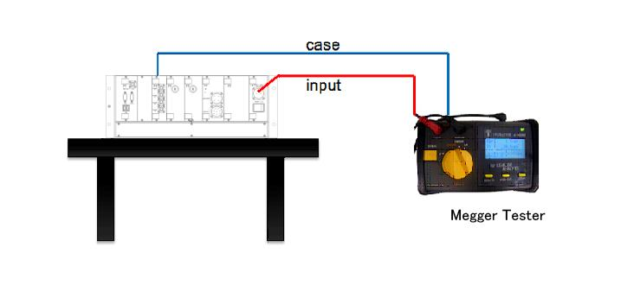
Figure 9. Expected Test Environment for Insulation Resistance Test
- Objective
Check the discharge & short first to check the insulation connecting the power input and case.

- Criteria
The insulation resistance must more than 10MΩ.

- Test Methodology
Measure the insulation resistance between all of the charged area and ground (-) using DC500V insulation resistance tester.

Voltage withstand Test
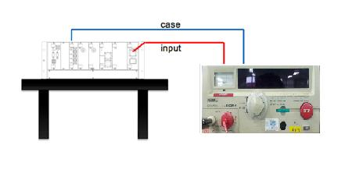
Figure 10. Expected Test Environment for Withstanding Voltage Tester.

- Objective
Test that there is no damage on the power input and chassis in the regulation voltage.

- Criteria
The test is passed if there is no insulation breakdown.
Apply the AC 1075V, 60Hz for 1 minute and confirm.

- Test Methodology
The voltage withstood between input terminal except of earth pin and earth stud. Refer to the above Test Configuration shown as Figure 10.

Temperature test
External Equipment operation check in temperature range between -35 ºC ~ 50 ºC and Internal Equipment operation check in temperature range between 0 ºC ~ 45 ºC which shall be checked with test certificate issued by External Test Facility.

- Criteria
There shall be no problem during the temperature test.

Dry heat test (IEC60068-2-2)
- Objective
Check the proper operation in high temperature.

- Criteria
There shall be no operation problem during the temperature test.

- Test Methodology
This shall be carried out for 12 hours at 55±3℃ during which the equipment under the test shall be powered. Check the operation at 55 degrees for 12 hours. And check the operation again at 25 degrees.

Test time: During and After
Temp(℃)
Check
55℃
Humidity(20%)

Check

25℃

Time(h)
12h
1h
1h

Damp heat test (IEC60068-2-30)
- Objective
Test not to occur the changes or damages because of the changes of temperature during the delivery.

- Criteria
Equipments shall be operated properly without any changes or damages.

- Test Methodology
This shall be carried out for 24 hours(1cycle) at 25℃~55℃ with relative humidity of 85±3% non- condensing. The specimen under the test shall not be powered. Test cycle: 1 cycles,

Check time: 24hour(1cycle)
55℃
12h
Temp(℃)
Time(h)
25℃
85%
12h
0%
1 cycle

Cooling test (IEC60068-2-1)

- Objective
Check the operation well in the low temperature.
The only Outside Cameras are applied
- Criteria
-External Equipment shall be operated well after aging test in -25 degrees for 12 hours.
-Internal Equipment shall be operated well after aging test in 0 degrees for 12 hours.
- Test Methodology
External Equipment: This shall be carried out for 12 hours at -25℃.
Internal Equipment: This shall be carried out for 12 hours at 0℃.
The specimen under the test shall be powered during test duration.
Check time: After
25℃
12h
Temp(℃)
-25℃
Check(External equipment)
1h
1h
Time(h)

Semi-Conductor Burn-in Test
- Objective
All boards in the DENVER RTD CCTV are subjected to be burn-in with the following temperature profile.
Considering the proof of the Semi-Conductor reliability inside PCB, TP 20.27.B (Reliability Standard), Burn-in Test mention on TP 20.28.D, will be standard.

- Criteria
After the test, there shall be no problem on assembling and operate well.

- Test Method
This Environmental Stress Screening (ESS) profile is based on Table 7.5-2 of the Reliability Toolkit: Commercial Practices Edition as published by the Reliability Information Analysis Center (RIAC). This ESS profile has been in use at Inter-M for electronics assemblies since DENVER RTD CCTV Proj.
Temperature Cycling Regimen
Characteristic | PWA¹ | Remark
Temperature range of hardware | -50°/+75℃ to -65°/+100℃
Temperature rate of change of hardware² | 10℃/min to 20℃/min
Stabilization criterion | Stabilization has occurred when the temperature of the slowest-responding element in the hardware being screened is within 5 to 15℃ of the specified temperature extreme³
Soak time of hardware at temperature extremes  - if unmonitored  - if monitored | 5 min
 | Long enough to perform functional testing
Number of cycles | 20 cycles to 40 cycles
Equipment condition | Unpowered
- PWA guidelines apply to individual PWAs and to modules, such as flow-through electronic module consisting of one or two PWAs bonded to a heat exchanger.
- Hardware temperature rate of change is limited by capabilities of ESS chambers.
- It is up to the designer of the screening regimen to decide which elements (such as parts, the solder joints, the PWAs, and the connectors) of the hardware must be selected to determine the extreme temperatures in the thermal cycle. The temperature histories of the various elements in the hardware being screened are determined by means of a thermal survey. If equipment is operating, stabilization criterion may need to be based on the stabilized rate of change of the product rather than absolute temperature.
* Exception: Camera Image sensor
(Specific temperature of Video Image Sensor is out of specification.)

EMC test: IEC 62236-3-2 (External Test Facility)
The following tests are performed.
No. | Title | Standard number
1 | Emission tests and limits | CISPR 11
2 | Radiated Emissions | CISPR 11
3 | Electrostatic Discharge immunity test | IEC 61000-4-2: Criterion B
4 | Immunity to Radio –Frequency Electromagnetic Fields | IEC 61000-4-3: Criterion A
5 | Electrical Fast Transient/Burst immunity test | IEC 61000-4-4: Criterion A
6 | Surges immunity test | IEC 61000-4-5: Criterion B
7 | Immunity to conducted disturbances inducted by radio-frequency filed | IEC 61000-4-6: Criterion A

Emission tests and limits
Shown in clause 2.16.1.1 and 2.16.1.2

Conducted Emissions
Testing is performed using the procedures contained in CISPR11
DC 37.5 V input to line port is measured.

- Criteria
The limits for conducted emission are as follows.
Frequency Range | Limits quasi – peak(Criteria)
9 kHz – 150 kHz | No limits
150 kHz – 500 kHz | 99 dBμV
500 kHz – 30 MHz | 93 dBμV

Radiated Emissions
Testing is performed using the procedures contained in CISPR11
Enclosure port is measured.
- Criteria
The limits for radiated emissions are as follows (10m distance).
Frequency Range | Field Strength(Criteria)
30 M – 230 MHz | 40 dBμV/m
230 M – 1 GHz | 47 dBμV/m

Immunity tests and severities
Performance criteria:
Criterion A
It will keep the condition for performance of equipment specification during the test or end of test:
Criterion B
The equipment performance shall be under standard during the test, but it shall be performed normally after the end of test.

Electrostatic Discharge immunity test
Testing is performed using the procedures contained in IEC 61000-4-2.
This test will be applied only to the equipment, which can be touched by operators of the train.
Performance Criterion B is applied.
Enclosure port is measured.
- Criteria
Equipment shall be operated well.
The test severity is as follows.
Discharge type | Contact Discharge | Air Discharge
Tested level | +/- 6.0 kV | +/- 8.0 kV

Immunity to Radio –Frequency Electromagnetic Fields
Testing is performed using the procedures contained in IEC 61000-4-3.
Performance Criterion A is applied.
Enclosure ports are measured.
The test severity is as follows.
Tested frequency | 80 MHz – 1 GHz
Field strength | 10 V/m
Amplitude modulation | 1kHz 80% AM
Polarity of the antenna | Horizontal and Vertical
Sweep rate | Under 1.5 x 10⁻³ decade/s

Electrical Fast Transient/Burst immunity test
Testing is performed using the procedures contained in IEC 61000-4-4.
Performance Criterion A is applied.
DC 37.5 V input to line port is subject to the test severity as follows.
Tested level | +/- 2.0 kV
Burst duration | 15 ms
Repetition rate | 5 kHz
Tr/Th | 5 ns/50 ns

Surges immunity test
Testing is performed using the procedures contained in IEC 61000-4-5.
Performance Criterion B is applied.
DC 37.5 V input to line is measured.
The test severity is as follows.
 | Line - Ground | Line - Line
Tested level | +/- 2 KV | +/- 1 KV
Tr/Th | 5 /50 us

Immunity to conducted disturbances inducted by radio-frequency filed
Testing is performed using the procedures contained in IEC 61000-4-6.
Performance Criterion A is applied.
DC 37.5 V input to line is measured. The test severity is as follows.
Frequency Range | 150 k – 80 MHz
Tested level | 10 Vrms
Amplitude modulated | 80% 1 kHz AM
Sweep rate | 1.5 x 10⁻³ decade/s
Source impedance | 150 ohm

Shock and Vibration test: IEC61373 (External Test Facility)
“Railway applications – Rolling stock equipment – Shock and vibrations tests” with test conditions: category 1, class A. Test severity and frequency range for Random vibration test is as follows:

- Objective
The objective of this section is to verify that the CCTV System can withstand appropriate shock and vibration levels for car mounted CCTV equipment

- Criteria
After the test, there shall be no problem on assembling and operate well.
The CCTV System must function properly during the test. At the completion of the tests, the CCTV System must pass the requirements of the production test specification with the exception of the hi-pot and megger tests

- Pre-inspection
If not performed prior to this test, perform the functional portion of the CCTV production test specification.
Frequency
(log scale)
ASD
(log scale)
Lower limit
Normal
Upper limit
9 dB/octave
x
5
f₁
ff1h
Hz
20
f₂
ff1h
Tolerance band ±3dB
on nominal spectrum
6 dB/octave

Vibration test
- Test Methodology
Test severity and frequency range for each vibration test is as follows:
Test | Severity & Frequency | Vertical | Transverse |  | Longitudinal
Random Vibration | ASD Level : [m/s²] ²/Hz | 0.0164 | 0.0041 |  | 0.0073
Random Vibration | RMS Value : [m/s²] | 0.75 | 0.37 |  | 0.50
Random Vibration | Frequency range | 5~20Hz : ASD level,  20~150Hz : -6dB/ octave
Simulated long life test  (by increased random vibration) | ASD Level : [m/s²] ²/Hz | 1.034 |  | 0.250 |  | 0.452
Simulated long life test  (by increased random vibration) | RMS Value : [m/s²] | 5.9 |  | 2.9 |  | 3.9
Simulated long life test  (by increased random vibration) | Test time | 5hr |  | 5hr |  | 5hr
Simulated long life test  (by increased random vibration) | Frequency range | 5~20Hz : ASD level,  20~150Hz : -6dB/ octave

Shock test
- Test Methodology
Test severity, pulse shape and direction for shock test is as follows:
Test | Vertical | Transverse | Longitudinal
Peak acceleration: [m/s²] | 30 | 30 | 50
Nominal Duration: [ms] | 30 | 30 | 30
Number of shocks:  Total 18 shocks | 6 shock  (positive 3 & negative 3) | 6 shock  (positive 3 & negative 3) | 6 shock  (positive 3 & negative 3)
Pulse shape | Half sine | Half sine | Half sine

Apply a series of three positive and three negative pulses at a level A of 3g and a nominal duration D of 30 milliseconds. The shock profile is shown in below Figure. During the performance of this test, allow an interval of 10 to 15 seconds between pulses.
2,5 D
2,1 D
D
-0.2A
Integration time = 1,5 D
Monitoring duration of shock tester = 2,4D
Lower bounds
Upper bounds
0.2A
Nominal bounds
Monitoring duration of vibration generator = 6D
0
0.2A
1.2A
A
0.8A

Waterproof and Dust Test: IEC 60529 (External Test Facility)
The Dust/Waterproof Testing is performed to ensure that the introduction of neither dust nor water at specified levels causes any degradation or failure of the equipment being tested. These tests will be performed in accordance with IEC 60529-IP66.

Waterproof test
- Test Method

Spray nozzle | Water jet hose nozzle(12.5 mm in diameter)
Water flow rate | 100 ℓ/min ± 5 %
Distance | 2.5 to 3.0 m
Duration | 1min/, at least 3min

Initial measurement: it checks normal operating of the sample before test starts.
Final measurement: It checks normal operating of the sample at the end of test.

Dust test
- Test Methodology

Powder density | Talcum powder 2 kg/
Depression | 2 kpa(20 mbar)
Duration | 8h

Initial measurement: it checks normal operating of the sample before test starts.
Final measurement: It checks normal operating of the sample at the end of test.
Inspection sheet
Project |  | Denver Fastrack Eagle Project |  |  |  | Test date |  |  | .
Equipment |  | Interior camera |  |  |  | Authorized  Supervisor
Manufacturer |  | Inter-M |  |  |  | I  N  S  P  E  C  TOR | Hyundai Rotem
Drawing. No. |  | DENVER-INT001 |  |  |  | I  N  S  P  E  C  TOR | Inter-M
Test type |  | Design Qualification Test |  |  |  | Test result
Measuring Instrument |  | Vernier Calipers, Weigh scale, Web browser, Drawing, Spec Sheet.
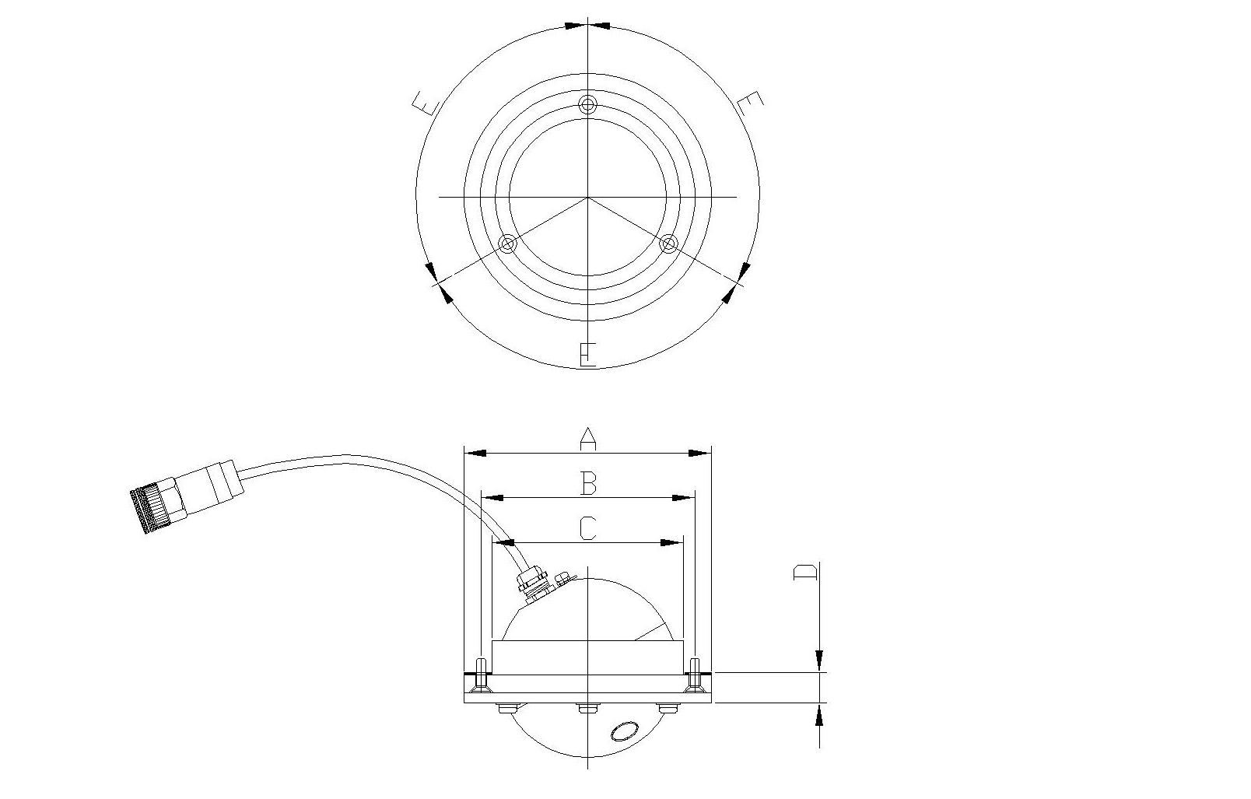

Test Items |  |  |  | Test Method and Criteria |  |  |  | Measured Data |  | Pass or Fail
Mechanical Inspection | Visual Inspection |  |  | To check that with drawings
Mechanical Inspection | Dimensional Check  (mm) |  |  | A | Φ4.33”[Φ110mm]
Mechanical Inspection |  |  |  | B | Φ3.74”[Φ95mm]
Mechanical Inspection |  |  |  | C | Φ3.35”[Φ85mm]
Mechanical Inspection |  |  |  | D | 0.53”[13.5mm]
Mechanical Inspection |  |  |  | E | 120º
Test items |  |  | Test criteria |  |  |  |  | Measured data |  | Pass or Fail
Appearance  Inspection |  |  | Check visually for crack defect or bad paintings or an abnormal appearance.  Check visually according to the approved drawing.  Check the status of fixing
Dimension examination |  |  | Check dimension visually according to the approved drawing.
Weight |  |  | Less than 1.0kg
PoE (Power Over Ethernet) Test |  |  | Check operation status test after connecting Cameras to LAN ports of PoE.
Video Resolution Variable Test |  |  | Change and check resolution change with Web Browser
Video Frame Rate Test |  |  | Change and check frame rate change with Web Browser
Protocol Test |  |  | TCP, UDP, IP, HTTP, DHCP, RTP, RTSP, Web Brower
Multi Streaming Test |  |  | Compression method check with web browser: H.264
Viewing Area |  |  | Horizontal: 120°  Vertical: 110°
Operation & Combination |  |  | Operation without problem
Aging |  |  | Operation without problem
Temperature Test |  |  | Check on test certificate in spec sheet.
EMI Test |  |  | It will be tested by external licensed facility, which has provision and certification of EMI Test. |  |  |  |  | It will be provided the certified test record
EMS Test |  |  | It will be tested by external licensed facility, which has provision and certification of EMS Test. |  |  |  |  | It will be provided the certified test record
Vibration & Shock Test |  |  | It will be tested by external licensed facility, which has provision and certification of Shock & Vibration. |  |  |  |  | It will be provided the certified test record
Recognition Test for Distance, |  |  | Write below Test sheet by setting Rotakin Chart on each Distance.
Remarks:
-ROTAKIN TEST
Distance  from camera | Criteria | Test Result
10m | Should be distinguishable whether it is human or not | □ Pass □ Fail
5m | Should be distinguishable whether who is male or female | □ Pass □ Fail
3m | Appearance should be identified | □ Pass □ Fail

Angle of view rang | Criteria | Test Result
Horizontal | Max 120˚ | □ Pas
Vertical □ Fail | Max 110˚ | □ Pass □ Fail

Project |  | Denver Fastrack Eagle Project |  |  |  | Test date
Equipment |  | Outside Camera |  |  |  | Authorized  Supervisor
Manufacturer |  | Inter-M |  |  |  | I  N  S  P  E  C  TOR | Hyundai Rotem
Drawing. No. |  | DENVER-OS001 |  |  |  | I  N  S  P  E  C  TOR | Inter-M
Test type |  | Design Qualification Test |  |  |  | Test result
Measuring Instrument |  | Vernier Calipers, Weigh scale, Web browser, Drawing, Spec Sheet.
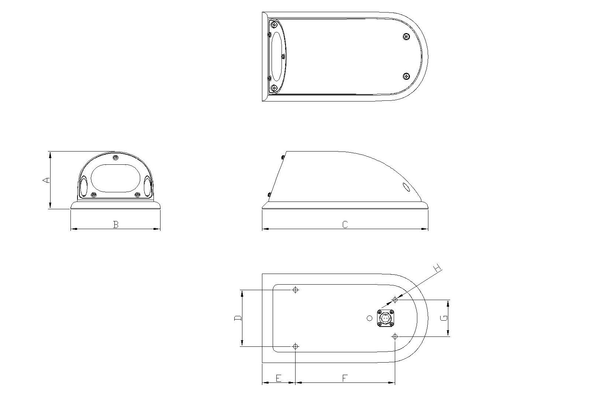

Test Items |  |  |  | Test Method and Criteria |  |  |  | Measured Data |  | Pass or Fail
Mechanical Inspection | Visual Inspection |  |  | To check that with drawings
Mechanical Inspection | Dimensional Check  (mm) |  |  | A | 3.43”[87mm±1]
Mechanical Inspection |  |  |  | B | 5.31”[135mm]
Mechanical Inspection |  |  |  | C | 9.84”[250mm]
Mechanical Inspection |  |  |  | D | 3.39”[86mm±1]
Mechanical Inspection |  |  |  | E | 1.97”[50mm±1]
Mechanical Inspection |  |  |  | F | 5.91”[150mm±1]
Mechanical Inspection |  |  |  | G | 2.2”[56mm±1]
Mechanical Inspection |  |  |  | H | Φ0.28”[Φ7mm]
Test items |  |  | Test criteria |  |  |  |  | Measured data |  | Pass or Fail
Appearance  Inspection |  |  | Check visually for crack defect or bad paintings or an abnormal appearance.  Check visually according to the approved drawing.  Check the status of fixing
Dimension examination |  |  | Check dimension visually according to the approved drawing.
Weight |  |  | Less than 3.3kg
PoE (Power Over Ethernet) Test |  |  | Check operation status test after connecting Cameras to LAN ports of PoE.
Video Resolution Variable Test |  |  | Change and check resolution change with Web Browser
Video Frame Rate Test |  |  | Change and check frame rate change with Web Browser
Protocol Test |  |  | TCP, UDP, IP, HTTP, DHCP, RTP, RTSP, Web Brower
Multi Streaming Test |  |  | Compression method check with web browser: H.264
Viewing Area |  |  | Horizontal: 35°  Vertical: 25°
Operation & Combination |  |  | Operation without problem
Aging |  |  | Operation without problem
Temperature Test |  |  | Check on test certificate in spec sheet.
EMI Test |  |  | It will be tested by external licensed facility, which has provision and certification of EMI Test. |  |  |  |  | It will be provided the certified test record
EMS Test |  |  | It will be tested by external licensed facility, which has provision and certification of EMS Test. |  |  |  |  | It will be provided the certified test record
Vibration & Shock Test |  |  | It will be tested by external licensed facility, which has provision and certification of Shock & Vibration. |  |  |  |  | It will be provided the certified test record
Waterproof and Dust test |  |  | It will be tested by external licensed facility, which has provision and certification of waterproof and dust. |  |  |  |  | It will be provided the certified test record
Recognition Test for Distance, |  |  | Write below Test sheet by setting Rotakin Chart on each Distance.
Remarks:
-ROTAKIN TEST
Distance from camera | Criteria | Test Result
20m | Should be noticeable Whether it is moving or not | □ Pass □ Fail
10m | Should be distinguishable to the object whi | h is man or not.  □ Pass □ Fail
5m | Appearance should be identifiable | □ Pass □ Fail

Angle of View range | Criteria | Test
Horizontal Result | Max 35˚ | □ Pass □ Fail
Vertical | Max 25˚ | □ Pass □ Fail

Lighting | Criteria | Test Result
WDR | WDR should be operat | d within 5-seconds on the lighting to camera  □
Pass □ Fail
Night | Criteria | Test Result
Day & Night | At 0.05-lux, Day & Night should | be operated  □ Pass □ Fail

Project |  | Denver Fastrack Eagle Project |  |  |  | Test date
Equipment |  | Front Facing Camera |  |  |  | Authorized  Supervisor
Manufacturer |  | Inter-M |  |  |  | I  N  S  P  E  C  TOR | Hyundai Rotem
Drawing. No. |  | DENVER-FFC001 |  |  |  | I  N  S  P  E  C  TOR | Inter-M
Test type |  | Design Qualification Test |  |  |  | Test result
Measuring Instrument |  | Vernier Calipers, Weigh scale, Web browser, Drawing, Spec Sheet.
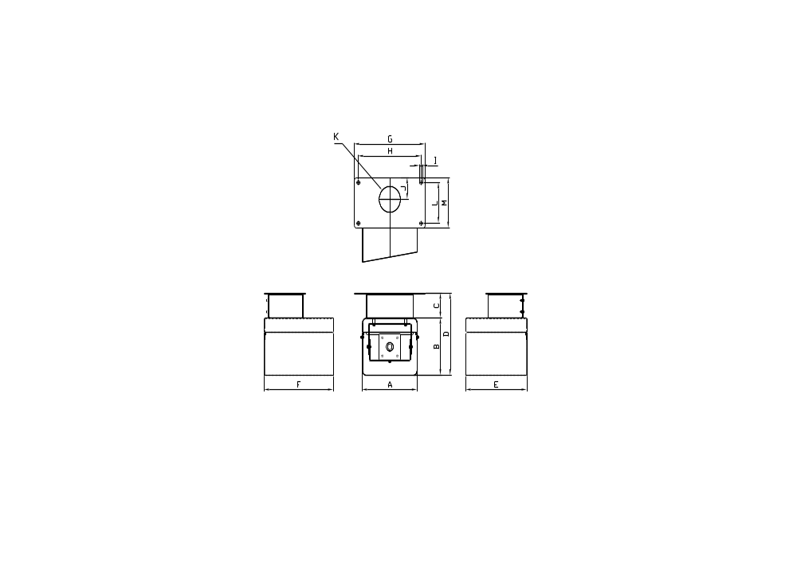
Test Items |  |  |  | Test Method and Criteria |  |  |  | Measured Data |  | Pass or Fail
Mechanical Inspection | Visual Inspection |  |  | To check that with drawings
Mechanical Inspection | Dimensional Check  (mm) |  |  | A | 5.51”[140mm]
Mechanical Inspection |  |  |  | B | 4.72”[120mm±1]
Mechanical Inspection |  |  |  | C | 2.05”[52mm±1]
Mechanical Inspection |  |  |  | D | 6.77”[172mm±1]
Mechanical Inspection |  |  |  | E | 6.1”[155mm]
Mechanical Inspection |  |  |  | F | 6.93”[176mm]
Mechanical Inspection |  |  |  | G | 7.09”[180mm]
Mechanical Inspection |  |  |  | H | 6.3”[160mm±1]
Mechanical Inspection |  |  |  | I | Φ 0.31”[Φ8mm]
Mechanical Inspection |  |  |  | J | 1.77”[45mm]
Mechanical Inspection |  |  |  | K | Φ2.13”[Φ54mm]
Mechanical Inspection |  |  |  | L | 3.35”[85mm±1]
Mechanical Inspection |  |  |  | F | 4.13”[105mm±1]
Test items |  |  | Test criteria |  |  |  |  | Measured data |  | Pass or Fail
Appearance  Inspection |  |  | Check visually for crack defect or bad paintings or an abnormal appearance.  Check visually according to the approved drawing.  Check the status of fixing
Dimension examination |  |  | Check dimension visually according to the approved drawing.
Weight |  |  | Less than 2.5kg
PoE (Power Over Ethernet) Test |  |  | Check operation status test after connecting Cameras to LAN ports of PoE.
Video Resolution Variable Test |  |  | Change and check resolution change with Web Browser
Video Frame Rate Test |  |  | Change and check frame rate change with Web Browser
Protocol Test |  |  | TCP, UDP, IP, HTTP, DHCP, RTP, RTSP, Web Brower
Multi Streaming Test |  |  | Compression method check with web browser: H.264
Viewing Area |  |  | Horizontal: 66°  Vertical: 48°
Operation & Combination |  |  | Operation without problem
Aging |  |  | Operation without problem
Temperature Test |  |  | Check on test certificate in spec sheet.
EMI Test |  |  | It will be tested by external licensed facility, which has provision and certification of EMI Test. |  |  |  |  | It will be provided the certified test record
EMS Test |  |  | It will be tested by external licensed facility, which has provision and certification of EMS Test. |  |  |  |  | It will be provided the certified test record
Vibration & Shock Test |  |  | It will be tested by external licensed facility, which has provision and certification of Shock & Vibration. |  |  |  |  | It will be provided the certified test record
Recognition Test for Distance, |  |  | Write below Test sheet by setting Rotakin Chart on each Distance.
Remarks:
-ROTAKIN TEST
Distance from camera | Criteria | Test Result
20m | Should be noticeable Whether it is moving or not | □ Pass □ Fail
10m | Should be distinguishable to the object which is man or not. | □ Pass □ Fail
5m | Appearance should be identifiable | □ Pass □ Fail

Angle of view rang |  | riteria  Test Re
Horizontalult | Max 66˚ | □ Pass □ Fail
Vertical | Max 48˚ | □ Pass □
Fail

Lighting | Criteria | Test Result
WDR | WDR should be operated within 5-seconds on the lighting to camera | □ Pass □ Fail

Night | Criteria | Test Result
Day & Night | At 0.05-lux, Day & | ight should be operated  □ Pass □ Fail

Project |  | Denver Fastrack Eagle Project |  |  |  | Test date
Equipment |  | CAB Camera |  |  |  | Authorized  Supervisor
Manufacturer |  | Inter-M |  |  |  | I  N  S  P  E  C  TOR | Hyundai Rotem
Drawing. No. |  | DENVER-CAB001 |  |  |  | I  N  S  P  E  C  TOR | Inter-M
Test type |  | Design Qualification Test |  |  |  | Test result
Measuring Instrument |  | Vernier Calipers, Weigh scale, Web browser, Drawing, Spec Sheet.
Test Items |  |  |  | Test Method and Criteria |  |  |  | Measured Data |  | Pass or Fail
Mechanical Inspection | Visual Inspection |  |  | To check that with drawings
Mechanical Inspection | Dimensional Check  (mm) |  |  | A | Φ4.33”[Φ110mm]
Mechanical Inspection |  |  |  | B | Φ3.74”[Φ95mm]
Mechanical Inspection |  |  |  | C | Φ3.35”[Φ85mm]
Mechanical Inspection |  |  |  | D | 0.53”[13.5mm]
Mechanical Inspection |  |  |  | E | 120º
Test items |  |  | Test criteria |  |  |  |  | Measured data |  | Pass or Fail
Appearance  Inspection |  |  | Check visually for crack defect or bad paintings or an abnormal appearance.  Check visually according to the approved drawing.  Check the status of fixing
Dimension examination |  |  | Check dimension visually according to the approved drawing.
Weight |  |  | Less than 1.0kg
PoE (Power Over Ethernet) Test |  |  | Check operation status test after connecting Cameras to LAN ports of PoE.
Video Resolution Variable Test |  |  | Change and check resolution change with Web Browser
Video Frame Rate Test |  |  | Change and check frame rate change with Web Browser
Protocol Test |  |  | TCP, UDP, IP, HTTP, DHCP, RTP, RTSP, Web Brower
Multi Streaming Test |  |  | Compression method check with web browser: H.264
Viewing Area |  |  | Horizontal: 120°  Vertical: 110°
Operation & Combination |  |  | Operation without problem
Aging |  |  | Operation without problem
Temperature Test |  |  | Check on test certificate in spec sheet.
EMI Test |  |  | It will be tested by external licensed facility, which has provision and certification of EMI Test. |  |  |  |  | It will be provided the certified test record.
EMS Test |  |  | It will be tested by external licensed facility, which has provision and certification of EMS Test. |  |  |  |  | It will be provided the certified test record.
Vibration & Shock Test |  |  | It will be tested by external licensed facility, which has provision and certification of Shock & Vibration. |  |  |  |  | It will be provided the certified test record.
Recognition Test for Distance, |  |  | It’s the camera to see the operator desk area  Located in the train cab.  So It will not be tested for the distance of  Recognition.
Remarks:
-ROTAKIN TEST
Distance  from camera | Criteria | Test Result
N.A. | Should be displayed the operator desk at inactive CAB through CCTV Monitor at active CAB | □ Pass □ Fail

Angle of view range | Criteria | Test Result
Horizontal | Max 120˚ | □ Pass □ Fail
Vertical | Max 110˚ | □ Pass □ Fail

Project |  | Denver Fastrack Eagle Project |  |  |  | Test date
Equipment |  | Digital Video Recorder |  |  |  | Authorized  Supervisor
Manufacturer |  | Inter-M |  |  |  | I  N  S  P  E  C  TOR | Hyundai Rotem
Drawing. No. |  | DENVER-DVR001 |  |  |  | I  N  S  P  E  C  TOR | Inter-M
Test type |  | Design Qualification Test |  |  |  | Test result
Measuring Instrument |  | Vernier Calipers, Drawing, Weight scale, DC Power Supply, Multi-meter
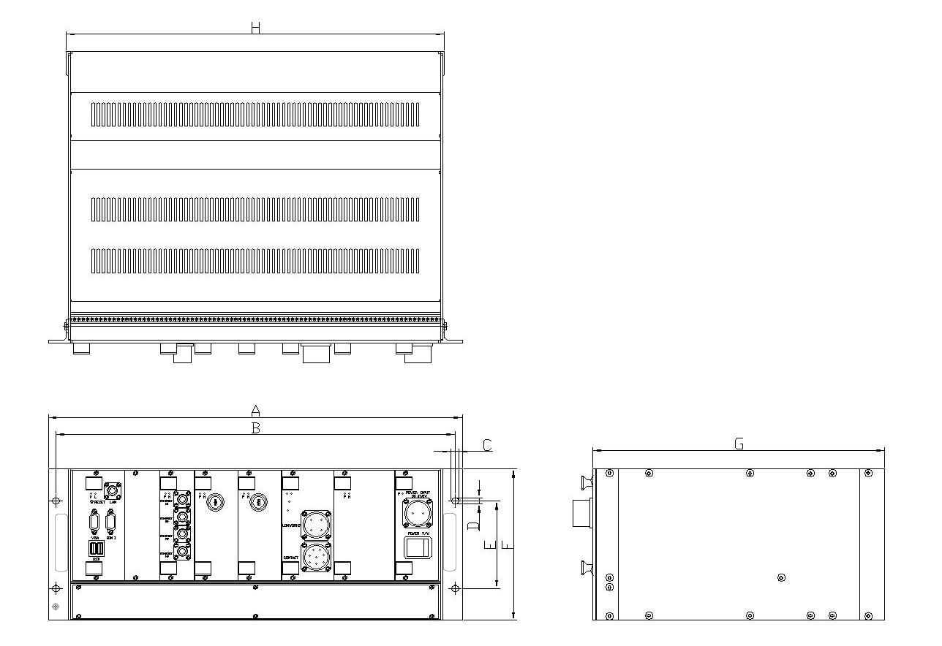
Test Items |  |  |  | Test Method and Criteria |  |  |  | Measured Data |  | Pass or Fail
Mechanical Inspection | Visual Inspection |  |  | To check that with drawings
Mechanical Inspection | Dimensional Check  (mm) |  |  | A | 19”[482.6mm]
Mechanical Inspection |  |  |  | B | 18.31”[465mm±1]
Mechanical Inspection |  |  |  | C | 0.35”[9mm±1]
Mechanical Inspection |  |  |  | D | 0.3”[7.5mm]
Mechanical Inspection |  |  |  | E | 4.02”[102mm±1]
Mechanical Inspection |  |  |  | F | 6.97[177mm]
Mechanical Inspection |  |  |  | G | 13.39”[340mm]
Mechanical Inspection |  |  |  | H | 17.36”[441mm±1]
Test items |  |  | Test criteria |  |  |  |  | Measured  data |  | Pass or Fail
Appearance  Inspection |  |  | Check visually for crack defect or bad paintings or an abnormal appearance.  Check visually according to the approved drawing.  Check the status of fixing
Dimension examination |  |  | Check dimension visually according to the approved drawing.
Weight |  |  | Less than 10kg
Recording |  |  | 72hours
HDD Capacity Test |  |  | Check on HDD capacity directly or check on control panel of O/S (500GX2)
Operation & Combination |  |  | Operation without problem
Aging |  |  | Operation without problem
Power supply change  (Performance Test) |  |  | When applying DC 37.5V (DC24V ~ 47V) at the room temperature, there should not be any failure on the performance.
Power Consumption |  |  | less than 100W (DC37.5 V)
Continuity test |  |  | Identify whether the wirings are connected properly. (Use the Wiring Diagram Drawing as the reference)
Insulation Resistance |  |  | More than 10Mohm
Voltage withstand test |  |  | After applying AC 1075V, 60Hz for one minute, there should not be any failure on the devices
Temperature Test |  |  | Check on test certificate in spec sheet.
EMI Test |  |  | It will be tested by external licensed facility, which has provision and certification of EMI Test. |  |  |  |  | It will be provided the certified test record
EMS Test |  |  | It will be tested by external licensed facility, which has provision and certification of EMS Test. |  |  |  |  | It will be provided the certified test record
Vibration & Shock Test |  |  | It will be tested by external licensed facility, which has provision and certification of Shock & Vibration. |  |  |  |  | It will be provided the certified test record
Remarks:

Project |  | Denver Fastrack Eagle Project |  |  |  | Test date
Equipment |  | PoE Hub |  |  |  | Authorized  Supervisor
Manufacturer |  | Inter-M |  |  |  | I  N  S  P  E  C  TOR | Hyundai Rotem
Drawing. No. |  | DENVER-POE001 |  |  |  | I  N  S  P  E  C  TOR | Inter-M
Test type |  | Design Qualification Test |  |  |  | Test result
Measuring Instrument |  | Vernier Calipers, Drawing, Weigh scale, DC Power Supply, Insulation Tester, Multi-meter
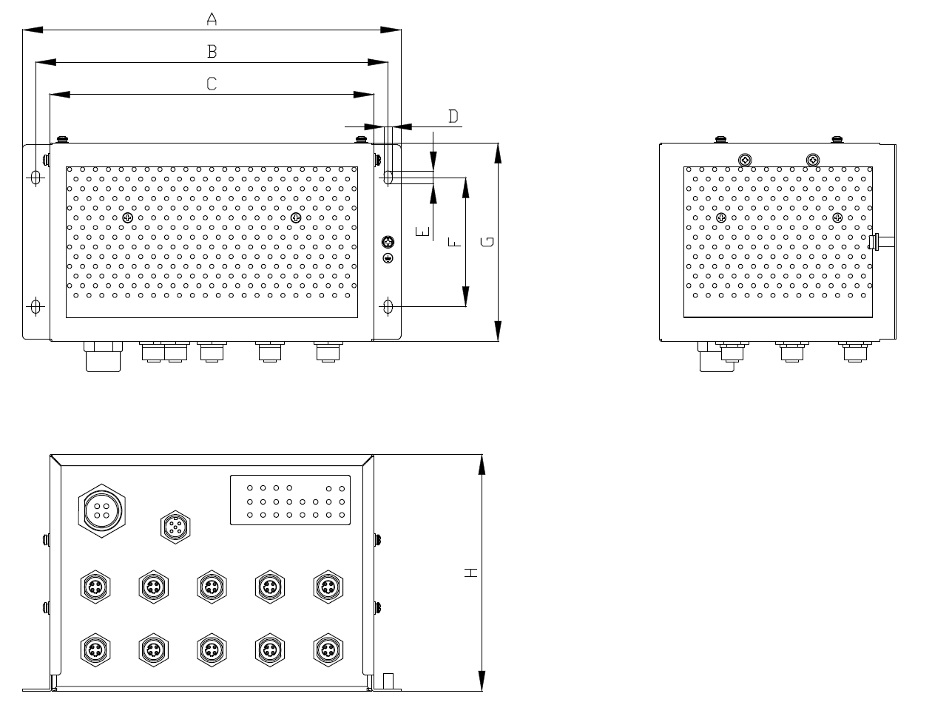

Test Items |  |  |  | Test Method and Criteria |  |  |  | Measured Data |  | Pass or Fail
Mechanical Inspection | Visual Inspection |  |  | To check that with drawings
Mechanical Inspection | Dimensional Check  (mm) |  |  | A | 9.21”[234mm]
Mechanical Inspection |  |  |  | B | 8.58”[218mm±1]
Mechanical Inspection |  |  |  | C | 7.9”[200.6mm]
Mechanical Inspection |  |  |  | D | 0.2”[5mm]
Mechanical Inspection |  |  |  | E | 0.31”[8mm]
Mechanical Inspection |  |  |  | F | 3.15[80mm±1]
Mechanical Inspection |  |  |  | G | 4.83”[122.6mm]
Mechanical Inspection |  |  |  | H | 5.77”[146.5mm]
Test items |  |  | Test criteria |  |  |  |  | Measured data |  | Pass or Fail
Appearance  Inspection |  |  | Check visually for crack defect or bad paintings or an abnormal appearance.  Check visually according to the approved drawing.  Check the status of fixing
Dimension examination |  |  | Check dimension visually according to the approved drawing.
Weight |  |  | Less than 5.4kg
PoE Test |  |  | Check operation PoE status test after connecting Cameras to LAN ports of PoE.
Operation & Combination |  |  | Operation without problem
Aging |  |  | Operation without problem
Power supply change  (Performance Test) |  |  | When applying DC 37.5V (DC24V ~ 47V) at the room temperature, there should not be any failure on the performance
Power Consumption |  |  | less than 160W (DC37.5 V)
Continuity test |  |  | Identify whether the wirings are connected properly. (Use the Wiring Diagram Drawing as the reference)
Insulation Resistance |  |  | More than 10Mohm
Voltage withstand test |  |  | After applying AC 1075V, 60Hz for one minute, there should not be any failure on the devices
Temperature Test |  |  | Check on test certificate in spec sheet.
EMI Test |  |  | It will be tested by external licensed facility, which has provision and certification of EMI Test. |  |  |  |  | It will be provided the certified test record
EMS Test |  |  | It will be tested by external licensed facility, which has provision and certification of EMS Test. |  |  |  |  | It will be provided the certified test record
Vibration & Shock Test |  |  | It will be tested by external licensed facility, which has provision and certification of Shock & Vibration. |  |  |  |  | It will be provided the certified test record
Remark :

Project |  | Denver Fastrack Eagle Project |  |  |  | Test date
Equipment |  | CCTV Monitor |  |  |  | Authorized  Supervisor
Manufacturer |  | Inter-M |  |  |  | I  N  S  P  E  C  TOR | Hyundai Rotem
Drawing. No. |  | DENVER-MON001 |  |  |  | I  N  S  P  E  C  TOR | Inter-M
Test type |  | Design Qualification Test |  |  |  | Test result
Measuring Instrument |  | Vernier Calipers, Weigh scale, Drawing, Spec Sheet, Multi-meter
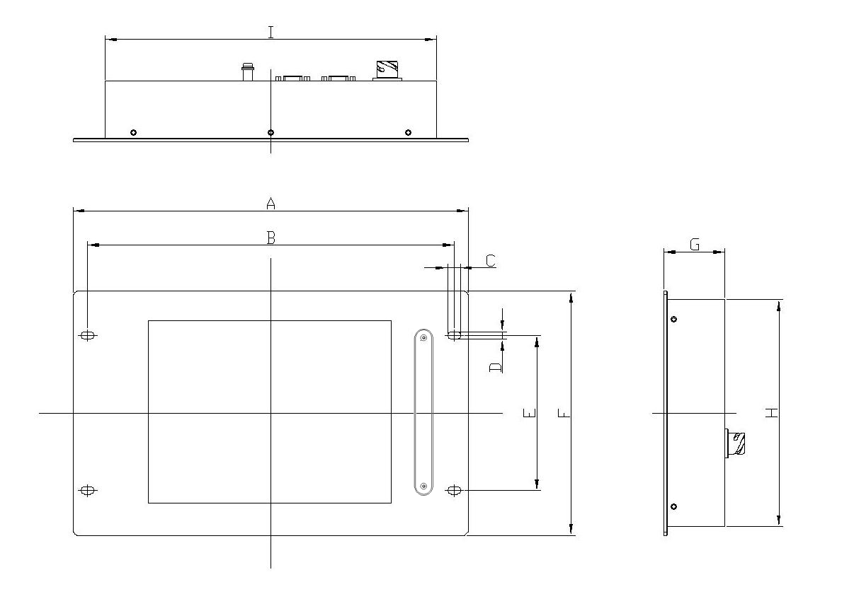
Test Items |  |  |  | Test Items |  |  |  |  | Measured Data |  | Pass or Fail
Mechanical Inspection | Visual Inspection |  |  | To check that with drawings
Mechanical Inspection | Dimensional Check  (mm) |  |  | A | 13.58”[345mm]
Mechanical Inspection |  |  |  | B | 12.6”[320mm±1]
Mechanical Inspection |  |  |  | C | 0.44”[11.3mm]
Mechanical Inspection |  |  |  | D | 0.26”[6.5mm±1]
Mechanical Inspection |  |  |  | E | 5.35”[136mm±1]
Mechanical Inspection |  |  |  | F | 8.43[214mm]
Mechanical Inspection |  |  |  | G | 2.04”[52mm]
Mechanical Inspection |  |  |  | H | 7.83”[199mm]
Mechanical Inspection |  |  |  | I | 10.98”[279mm]
Test items |  |  | Test criteria |  |  |  |  | Measured data |  |  | Pass or Fail
Appearance  Inspection |  |  | Check visually for crack defect or bad paintings or an abnormal appearance.  Check visually according to the approved drawing.  Check the status of fixing
Dimension examination |  |  | Check dimension visually according to the approved drawing.
Weight |  |  | Less than 3.4kg
Display Resolution |  |  | Check the video display of laptop computer and whether or not the resolution of XVGA(1024x768) is provided after being connected to terminal.
Operation & Combination |  |  | Operation without problem
Aging |  |  | Operation without problem
Temperature Test |  |  | Check on test certificate in spec sheet.
Continuity test |  |  | Identify whether the wirings are connected properly. (Use the Wiring Diagram Drawing as the reference)
Insulation Resistance |  |  | More than 10Mohm
Voltage withstand test |  |  | After applying AC 1075V, 60Hz for one minute, there should not be any failure on the devices
EMI Test |  |  | It will be tested by external licensed facility, which has provision and certification of EMI Test.
EMS Test |  |  | It will be tested by external licensed facility, which has provision and certification of EMS Test.
Vibration & Shock Test |  |  | It will be tested by external licensed facility, which has provision and certification of Shock & Vibration.
Remarks:

Project |  | Denver Fastrack Eagle Project |  |  |  | Test date
Equipment |  | JUMPER COUPLER |  |  |  | Authorized  Supervisor
Manufacturer |  | Inter-M |  |  |  | I  N  S  P  E  C  TOR | Hyundai Rotem
Drawing. No. |  | DENVER-JC001 |  |  |  | I  N  S  P  E  C  TOR | Inter-M
Test type |  | Design Qualification Test |  |  |  | Test result
Measuring Instrument |  | Tape measure, Vernier Calipers
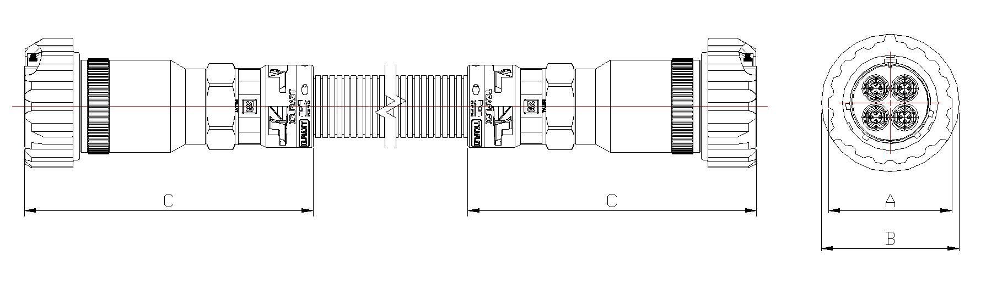

Test Items |  |  |  | Test Items |  |  |  |  | Measured Data |  | Pass or Fail
Mechanical Inspection | Visual Inspection |  |  | To check that with drawings
Mechanical Inspection | Dimensional Check  (mm) |  |  | A | 2.68”[68mm±0.2]
Mechanical Inspection |  |  |  | B | 2.99”[76mm±0.2]
Mechanical Inspection |  |  |  | C | 6.46”[164mm±1.0]
Test items |  |  | Test criteria |  |  |  |  | Measured data |  |  | Pass or Fail
Appearance  Inspection |  |  | Check visually for crack defect or bad paintings or an abnormal appearance.  Check visually according to the approved drawing.  Check the status of fixing
Dimension examination |  |  | Check dimension visually according to the approved drawing.
Waterproof and Dust test |  |  | It will be tested by external licensed facility, which has provision and certification of waterproof and dust. |  |  |  |  | It will be provided the certified test record
Remarks:

Project |  | Denver Fastrack Eagle Project |  |  |  | Test date
Equipment |  | RECEPTACL |  |  |  | Authorized  Supervisor
Manufacturer |  | Inter-M |  |  |  | I  N  S  P  E  C  TOR | Hyundai Rotem
Drawing. No. |  | DENVER-RE001 |  |  |  | I  N  S  P  E  C  TOR | Inter-M
Test type |  | Design Qualification Test |  |  |  | Test result
Measuring Instrument |  | Tape measure, Vernier Calipers
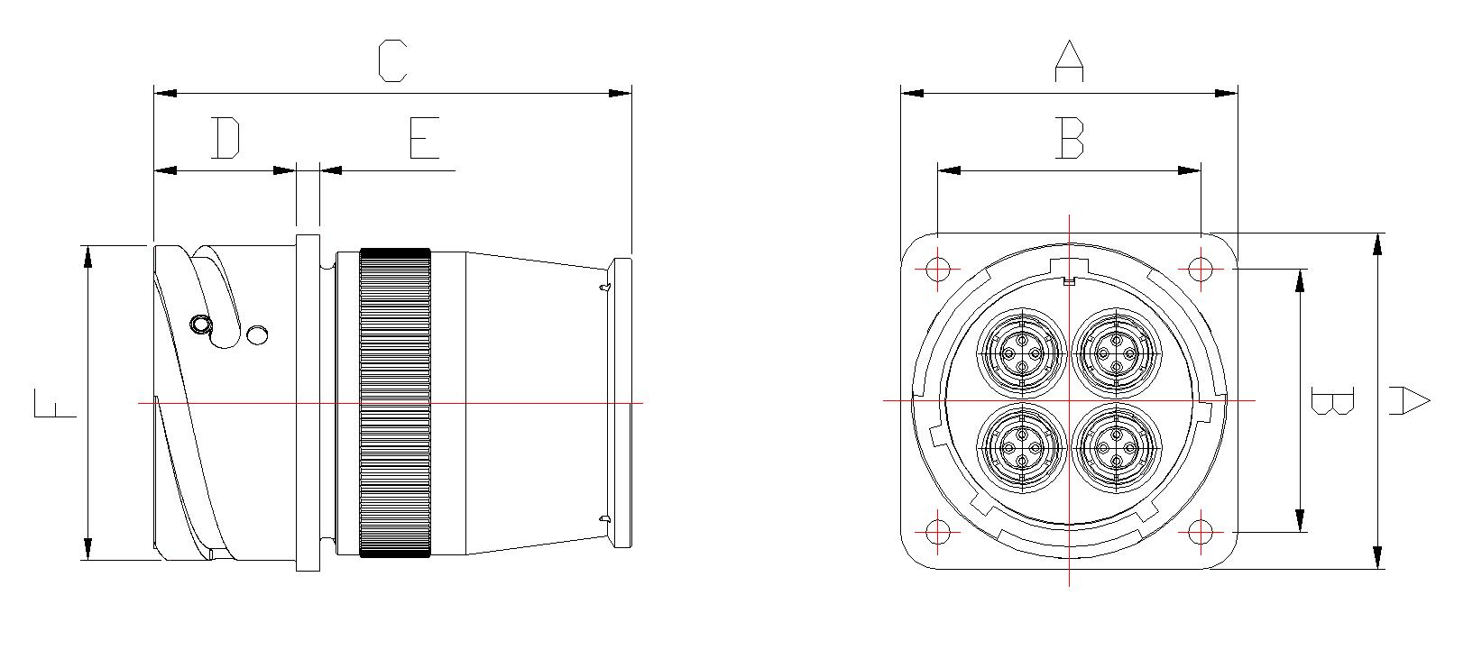
Test Items |  |  |  | Test Items |  |  |  |  | Measured Data |  | Pass or Fail
Mechanical Inspection | Visual Inspection |  |  | To check that with drawings
Mechanical Inspection | Dimensional Check  (mm) |  |  | A | 1.75”[44.5mm±0.1]
Mechanical Inspection |  |  |  | B | 2.24”[57mm±0.2]
Mechanical Inspection |  |  |  | C | 3.35”[85mm±1]
Mechanical Inspection |  |  |  | D | 0.95”[24.05mm]
Mechanical Inspection |  |  |  | E | 0.16”[4mm]
Mechanical Inspection |  |  |  | F | Φ 2.1”[Φ 53.4mm]
Test items |  |  | Test criteria |  |  |  |  | Measured data |  |  | Pass or Fail
Appearance  Inspection |  |  | Check visually for crack defect or bad paintings or an abnormal appearance.  Check visually according to the approved drawing.  Check the status of fixing
Dimension examination |  |  | Check dimension visually according to the approved drawing.
Waterproof and Dust test |  |  | It will be tested by external licensed facility, which has provision and certification of waterproof and dust. |  |  |  |  | It will be provided the certified test record
Remarks:

